Name: V.Sai Saketh Roll No:2520090055
Skill week - 4

Step 1: Create the Customer table with customer ID, name, phone number and email details.
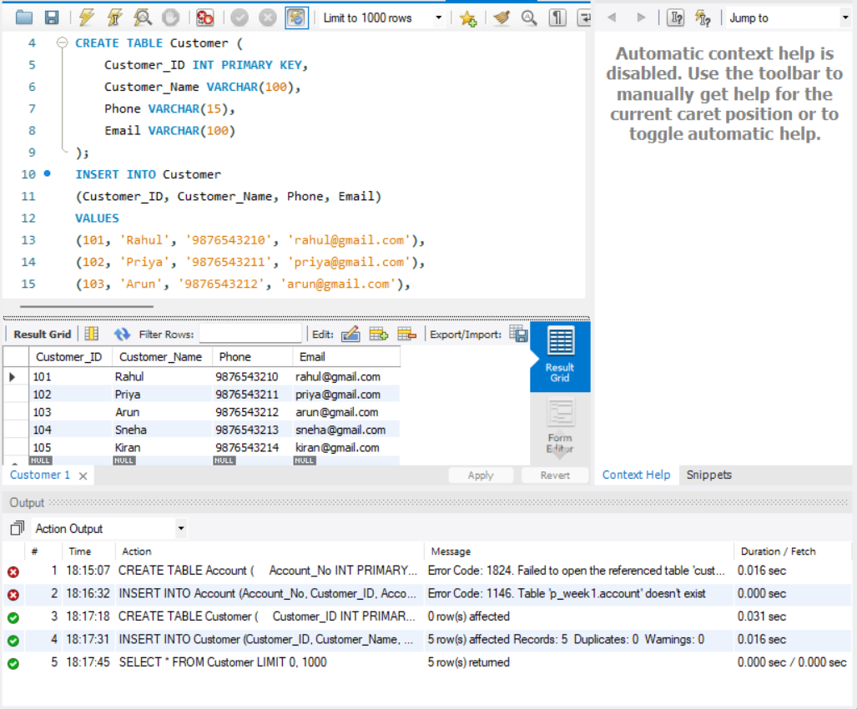

Step 2: Verify the Customer table and display the inserted customer records.

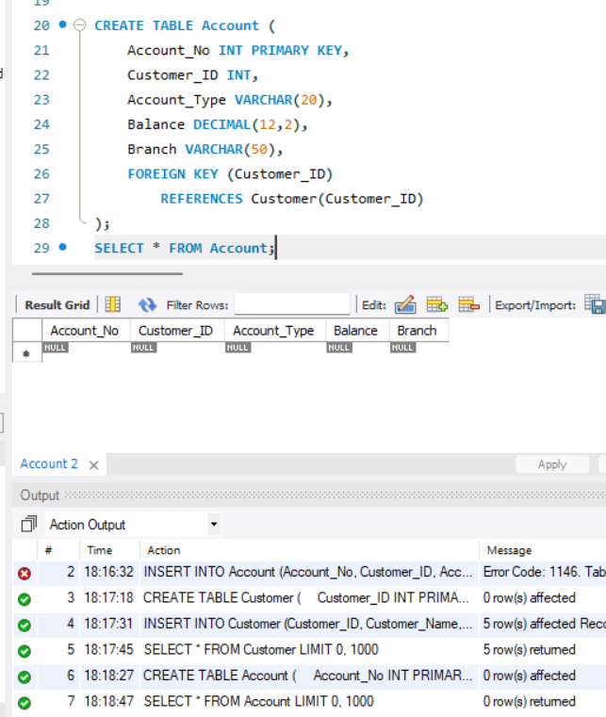

Step 3: Create the Account table and connect it to Customer using a foreign key.
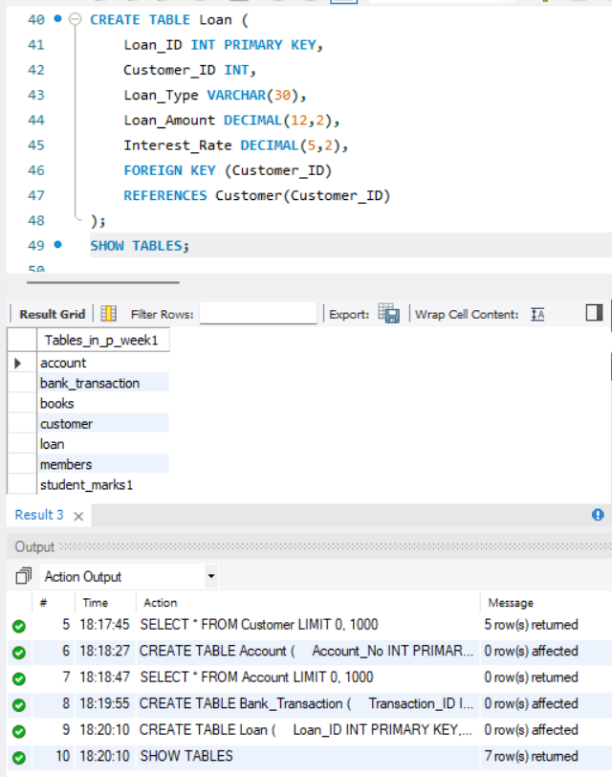

Step 4: Create the Bank_Transaction and Loan tables for banking transactions and loan details.
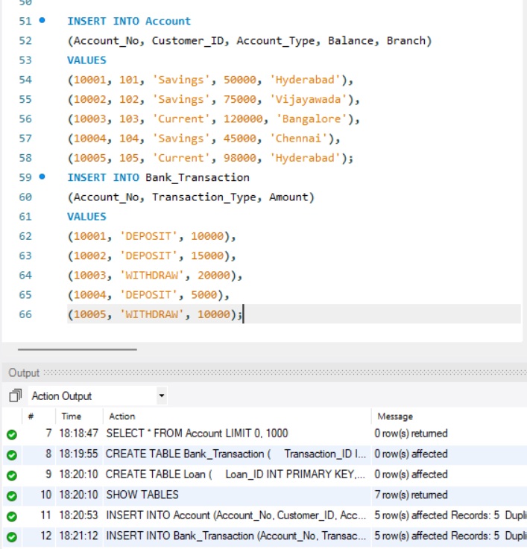

Step 5: Insert account records with account type, balance and branch information.
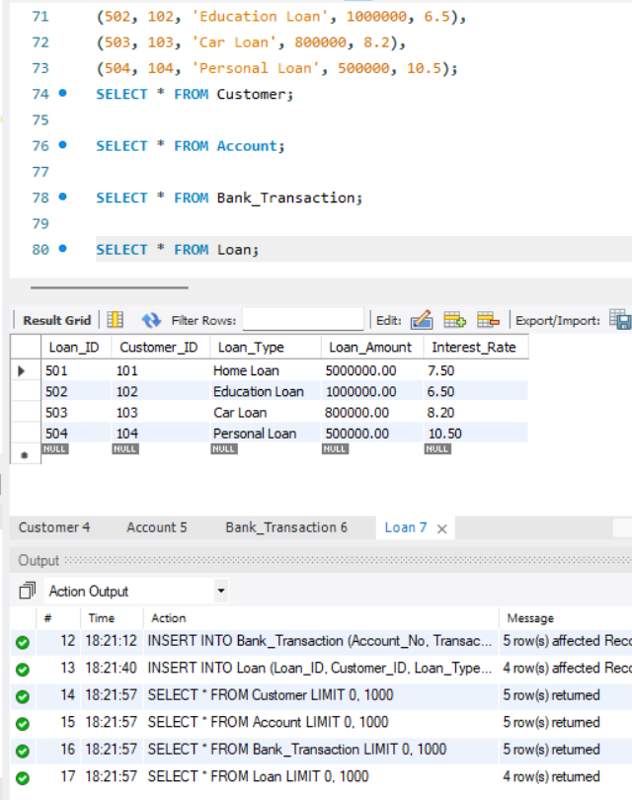

Step 6: Insert deposit and withdrawal transaction records for the accounts.
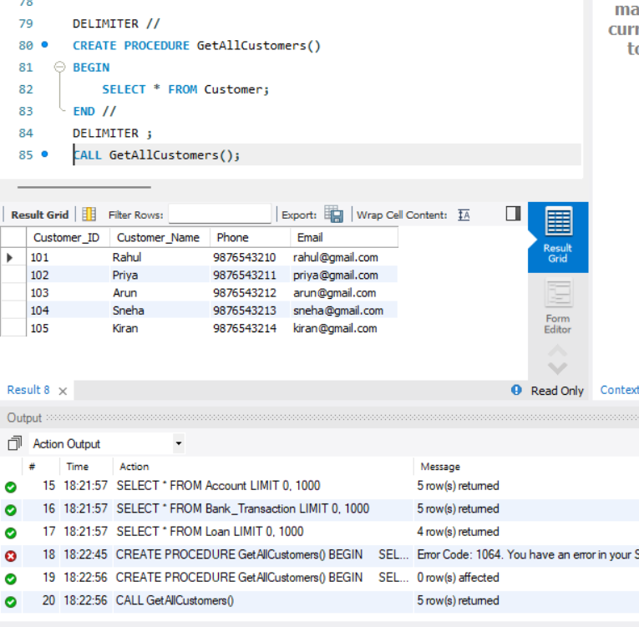

Step 7: Insert loan records containing loan type, amount and interest rate.
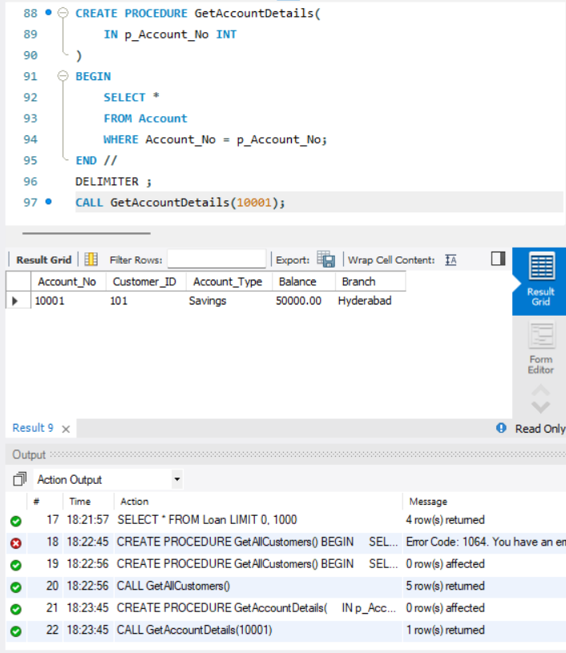

Step 8: Display the Customer, Account, Bank_Transaction and Loan records using SELECT queries.
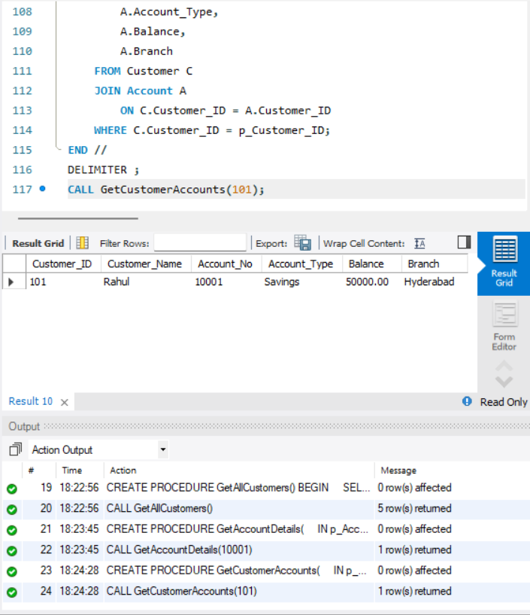

Step 9: Create and execute GetAllCustomers() to retrieve all customer details.
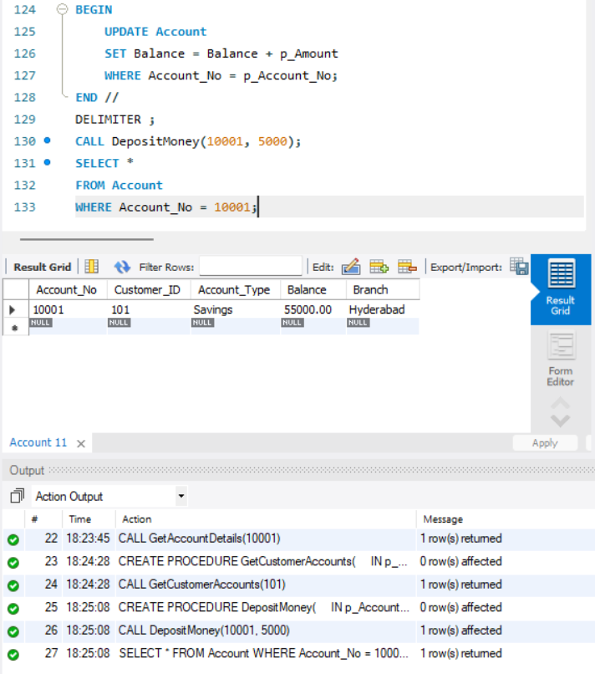

Step 10: Create and execute GetAccountDetails() to retrieve details for a specified account.
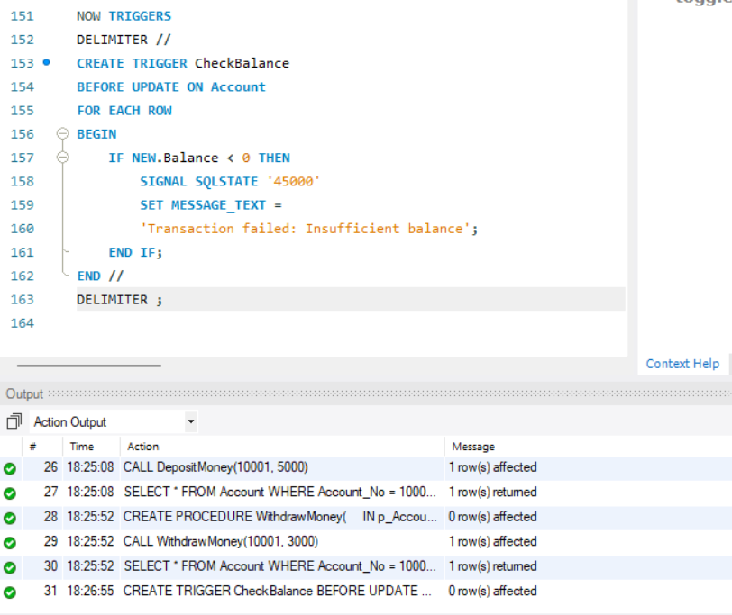

Step 11: Create GetCustomerAccounts() to display the account details of a selected customer.
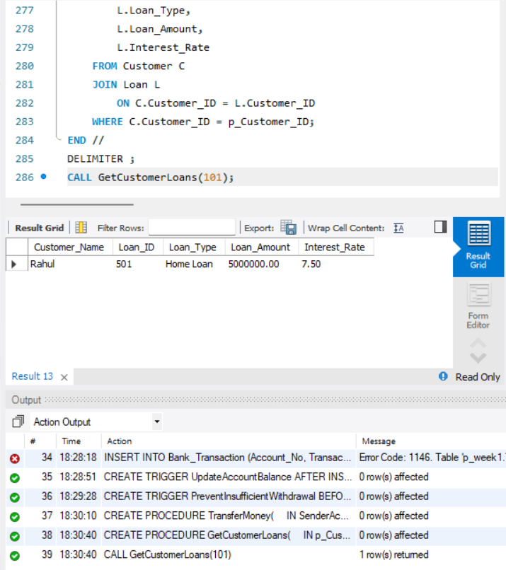

Step 12: Create DepositMoney() and update the account balance after depositing money.
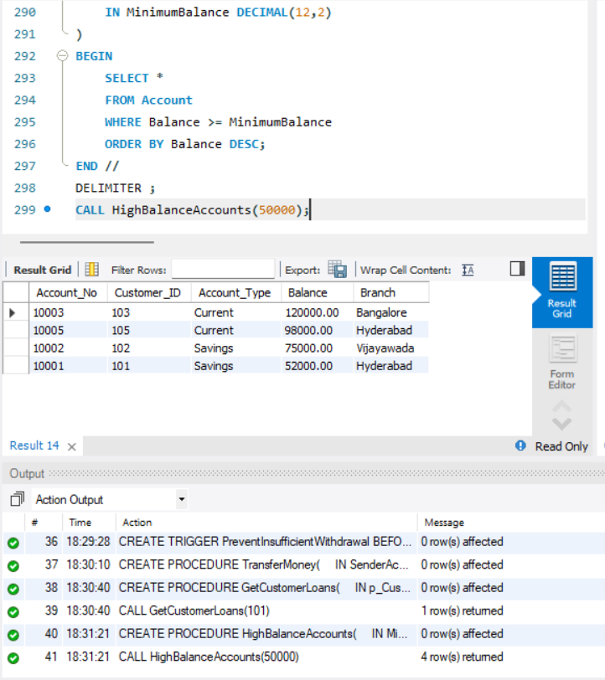

Step 13: Create balance-checking and transaction triggers to validate banking operations.
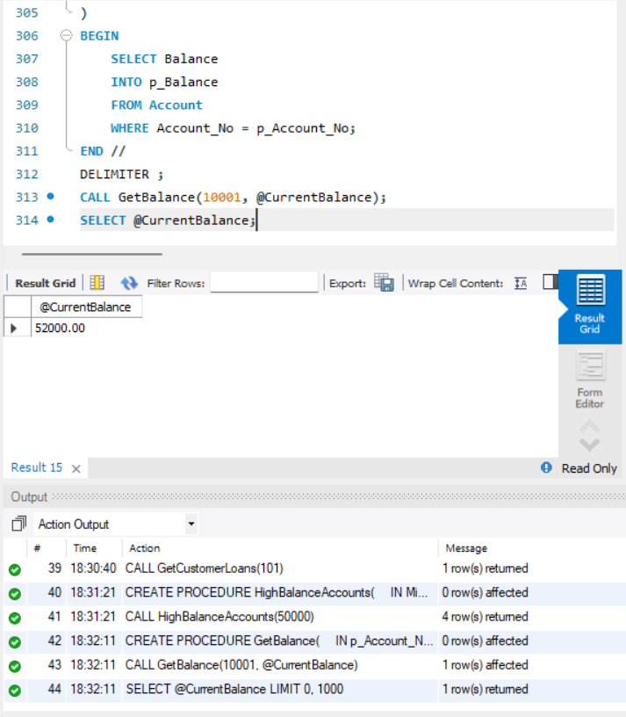

Step 14: Create GetCustomerLoans() to retrieve loans belonging to a selected customer.
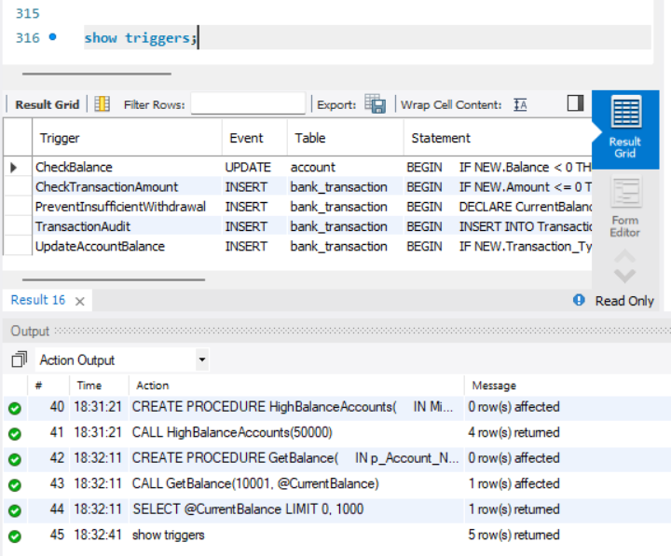

Step 15: Create HighBalanceAccounts() and GetBalance() to retrieve and check account balances.
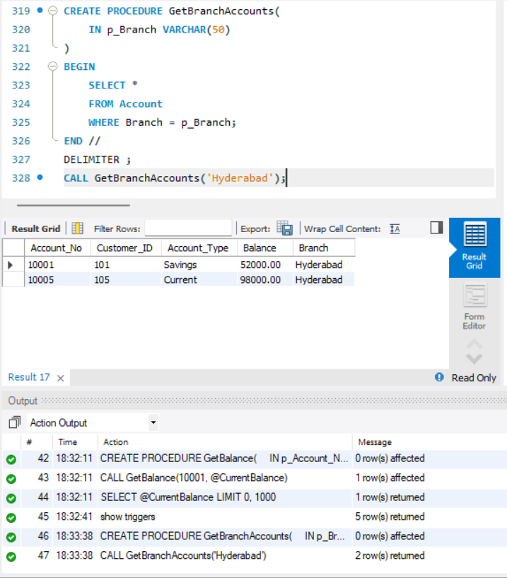

Step 16: Display the available triggers and create GetBranchAccounts() for branch-wise accounts.
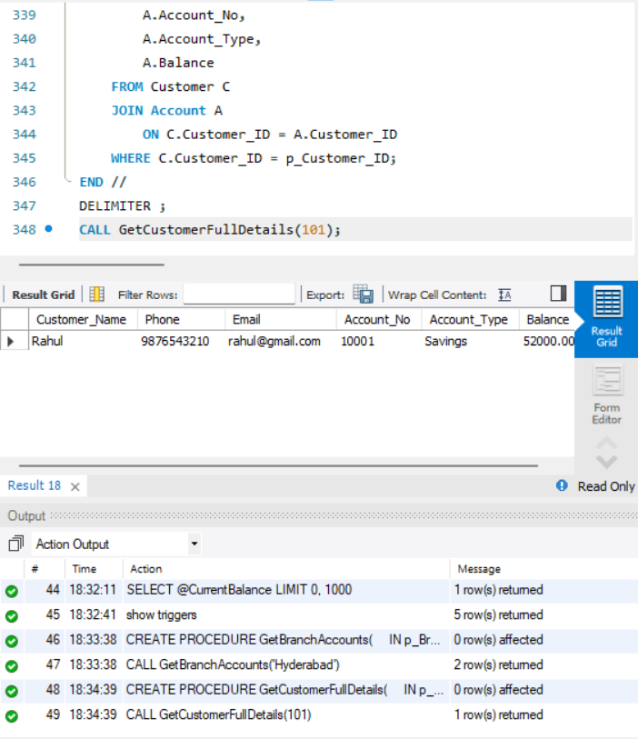

Step 17: Create GetCustomerFullDetails() and GetTotalCustomerBalance() to retrieve complete customer and balance information.
